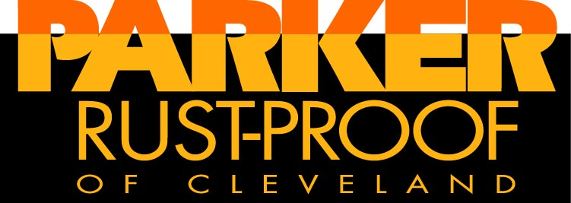
CAPABILITIES
CHEMICAL PROCESSING
Zinc & Manganese Phosphates
Automated Rack & Barrel Processing
Small & Large Parts up to 25 feet
Nuclear, Aerospace & Military Approved
Mechanical Cleaning & Blasting
CARC, Industrial, & MIL Painting
Passivating & Torq-Tech Process
Masterlube Products & Processes
Reactive Soap & Bonderlube
Dry Film & Cold Forging Lubricants
Chemlock, Everlube & Sandstrom
Black Oxide for mild steel
In-House Testing Laboratory
METAL SERVICES
Precision Cut Bar Stock to 16” dia
Stainless, Aluminum, & Carbon Steels
Tube & Bar - Cut & Chamfer
Press-Ready, Pre-Lubricated Slugs for cold impact extrusions
VALUE ADDED
Packaging/ Labeling
Salt Spray & Cleanliness Testing
Bake for Hydrogen embrittlement relief
Material Storage & Stocking
Over 100,000 sq ft of mfg space

The Original House of Parkerizing
FAST TURNAROUND

ITAR REGISTERED
Certificate # M19192 exp. 10/31/22

AS 9100D REGISTERED
Since 2011
ISO 9001:2008 REGISTERED
cert# A-552-AS exp. 4/8/2022
FEDERAL FIREARMS LICENSE

CAGE CODE #3Z878

NADCAP REGISTERED
for chemical processing

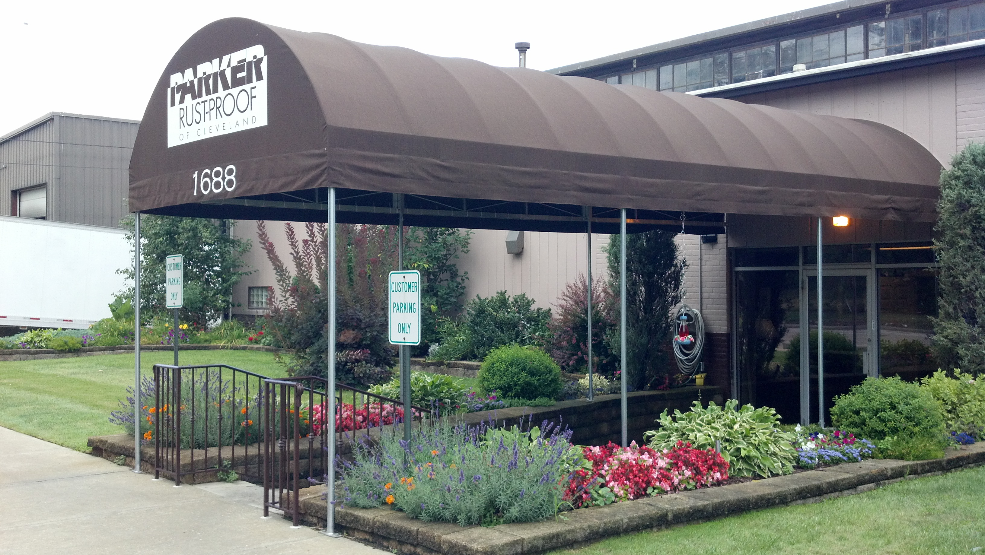

1688 Arabella Road Cleveland, OH 44112 (216) 481-7400 x122 fax (216) 481-8645
visit us on the web at www.parkerhq.com or email inquiries to sales@parkerhq.com

In October of 1918, The Parker Rust-Proof Company of Ohio became a job shop licensee of the Parker Rust-Proof Company of Detroit MI. During the next several years, there were tremendous break-throughs and discoveries in the rust-proofing process, and it was adopted by the automotive and appliance industry. During World War II, Parker played an important role in the defense industry; our coatings were applied to component parts of armaments, airplanes and tanks, stampings and fasteners. Today as we approach our 100th anniversary, we are the only remaining original job shop licensee that still applies genuine Parkerizing, Parco Lubrite, and Bonderite/Bonderlube coatings that were developed by our namesake. We have acquired updated equipment, technical knowledge, and experience unequalled in our field. Our metal finishing specialties include zinc and manganese phosphate coatings, reactive and non-reactive lubricant soaps, blackening, spray coating, and cleaning. Both barrel and rack processing of production quantities and small lots of ferrous and non-ferrous materials is available; our four automated and manual processing lines can accommodate parts as large as 22 feet in length and as heavy as four thousand pounds. Regardless of the lot size, each order receives careful review and handling, quality treatment and prompt service. We are highly committed to meeting the aerospace, nuclear, military and industrial specifications required by our customers and have undertaken a rigorous schedule of quality testing and process development to accomplish this. Today, Parker’s continuing expansion, along with our dedication to the highest quality standards in the industry and a strong emphasis on customer service has made us the first choice in metal finishing for customers around the world. Our trained and experienced laboratory staff stands behind their certifications. Each load is scrutinized for visual defects and subjected to the most rigorous tests in the industry before you receive it, so you never have to worry that your customer will be disappointed. Our customers trust us to do final inspection and, in many cases, package,+ barcode, and ship the product to the final user without ever seeing the finished material. This improves your bottom line by minimizing inspection, transportation, and inventory costs. We coat to over 500 industrial, military, aerospace, and nuclear specifications, but if you don’t see the one you are looking for on our website, we can develop and write a unique specification just like we have done for Cummins Engine and many other customers. Parker’s excellent QA system is built to deliver total satisfaction, worry-free!
Since we first opened our doors, our primary motivating force has been you, the customer. We believe in customer satisfaction through quality production, and maintain a high level of commitment to exceptional customer service, including the fastest turnaround in the industry. It all adds up to a higher total value!

